# Pydantic Schema to Neo4j & Extraction performance

When having large number of keys and values!

## Neo4j Database Schema:

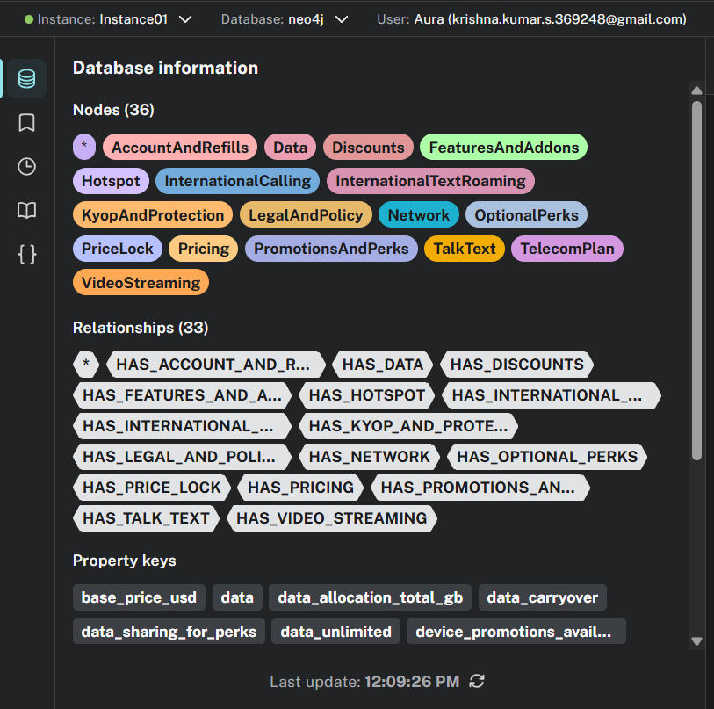

## Query and Response

### Scenario 1

Query:

/* all speed info */

MATCH (t:TelecomPlan)-[HAS_NETWORK]->(n:Network)

RETURN t.plan_name, n.network_speed_claim_source, n.network_types_compatible, n.network_types_used, n.network_variability_disclaimer, n.network_4glte_device_required, n.network_5g_requirements, n.network_5g_uwb_included, n.network_5g_uwb_speed_comparison

Response:

| t.plan_name | n.network_speed_claim_source | n.network_types_compatible | n.network_types_used | n.network_variability_disclaimer | n.network_4glte_device_required | n.network_5g_requirements | n.network_5g_uwb_included | n.network_5g_uwb_speed_comparison |
| --- | --- | --- | --- | --- | --- | --- | --- | --- |
| Unlimited Ultimate | OoklaÂ® Speedtest IntelligenceÂ® data from Q1-Q2 2024 | null | 5G, 4G LTE | null | null | null | yes | 4X faster than Verizon's regular 5G in the U.S. |
| $40 Unlimited Talk and Text plan | null | 4G LTE and 5G Network | null | Actual availability, coverage, and speed may vary. | A 4G LTE capable device is required for 4G LTE network access. | Access to 5G requires a 5G-capable device in a 5G coverage area | null | null |
| Platinum Unlimited | null | null | LTE | In times of congestion, your data may be temporarily slower than other traffic. | null | Access to 5G requires a 5G-capable device in a 5G coverage area. | null | null |

### Scenario 2

Query:

/* all perks */

MATCH (t:TelecomPlan)-[HAS_FEATURES_AND_ADDONS]->(f:FeaturesAndAddons)

RETURN t, f

Response:

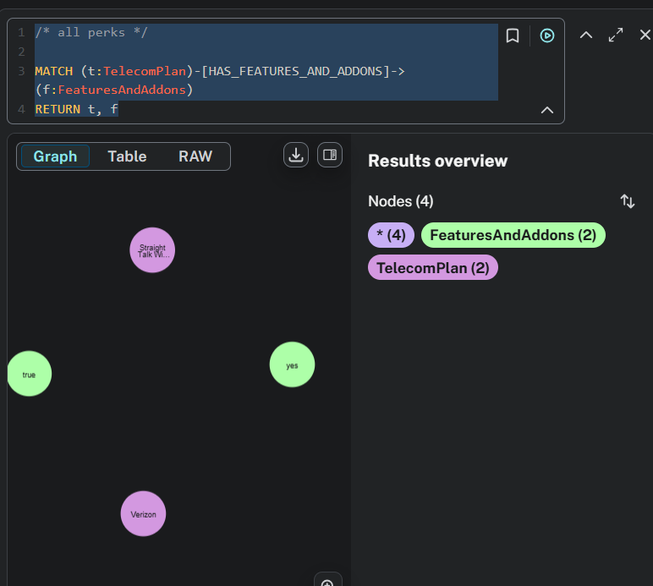

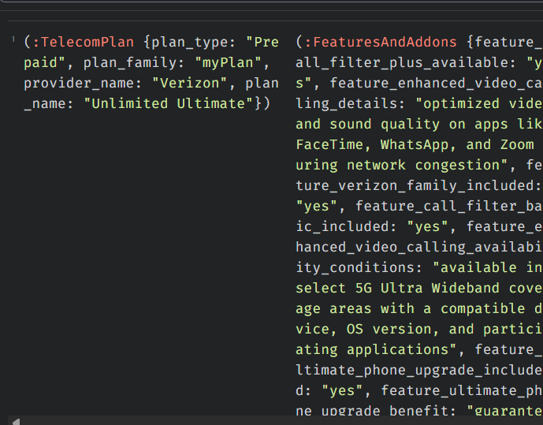

| **provider_name** | **plan_name** | **plan_type** | **plan_family** | **feature / perk** | **value** |
| --- | --- | --- | --- | --- | --- |
| Verizon | Unlimited Ultimate | Prepaid | myPlan | feature_call_filter_plus_available | yes |
| Verizon | Unlimited Ultimate | Prepaid | myPlan | feature_enhanced_video_calling_details | optimized video and sound quality on apps like FaceTime, WhatsApp, and Zoom during network congestion |
| Verizon | Unlimited Ultimate | Prepaid | myPlan | feature_verizon_family_included | yes |
| Verizon | Unlimited Ultimate | Prepaid | myPlan | feature_call_filter_basic_included | yes |
| Verizon | Unlimited Ultimate | Prepaid | myPlan | feature_enhanced_video_calling_availability_conditions | available in select 5G Ultra Wideband coverage areas with a compatible device, OS version, and participating applications |
| Verizon | Unlimited Ultimate | Prepaid | myPlan | feature_ultimate_phone_upgrade_included | yes |
| Verizon | Unlimited Ultimate | Prepaid | myPlan | feature_ultimate_phone_upgrade_benefit | guarantees the best phone deals for new and existing customers |
| Straight Talk Wireless | Platinum Unlimited | — | — | perk_walmartplus_included | TRUE |
| Straight Talk Wireless | Platinum Unlimited | — | — | perk_walmartplus_benefits_list_string | Free delivery ($35 order minimum, restrictions apply). Free shipping (excludes most Marketplace items, freight & certain location surcharges). Paramount+ Essential plan only, separate registration required. Fuel discount (varies by location & station, subject to change). |

### Scenario 3

Query:

/* all international details */

MATCH (t:TelecomPlan)-[HAS_INTERNATIONAL_CALLING]->(ic:InternationalCalling)

MATCH (t)-[HAS_INTERNATIONAL_ROAMING]->(ir:InternationalTextRoaming)

RETURN t.plan_name, ic.international_call

Response:

